
COMSATS University Islamabad,
Abbottabad Campus

SOFTWARE DESIGN DESCRIPTION
(SDD DOCUMENT)
for
KOJLO
Version 1.0
By
Sayyam Tahir CIIT/SP23-BSE-014/ATD
Nouman Khan CIIT/SP23-BSE-012/ATD
Kazim Shauket CIIT/SP23-BSE-024/ATD

Supervisor
Muhammad Tariq Baloch

Bachelor of Science in Software Engineering (2023-2027)

Contents
1.Introduction 9
2.Design methodology and software process model 9
3. System overview 10
3.1Architectural design 11
4.Design models 14
4.1 Class Diagram 14
4.2 Sequence Diagram 15
4.3 State Transition Diagram 17
5. Data design 18
5.2 Data dictionary 19
6.Algorithm & Implementation 22
7.Software requirements traceability matrix 28
8.Human interface design 29
8.1 Screen images 30

Revision History
Name | Date | Reason for changes | Version

Application Evaluation History

Comments (by committee)  *include the ones given at scope time both in doc and presentation | Action Taken

Supervised by
Muhammad Tariq
Signature______________

1.Introduction
Khojlo is a mobile and web-based business discovery platform designed to improve the visibility of newly established, affordable, and value-driven local businesses. The platform enables users to discover, search, compare, and explore businesses while allowing business owners to manage verified business profiles. Its primary objective is to bridge the gap between customers and local businesses by enhancing accessibility, increasing business visibility, and supporting informed decision-making.
The system provides user authentication and profile management, business registration and profile management, and a business discovery feed that highlights newly opened and trending businesses. It includes search, filtering, and comparison features that allow users to find businesses based on keywords, category, location, and price, and compare them based on pricing, services, and overall value.
Khojlo also incorporates a reviews and ratings system, Google Maps integration for location-based discovery and navigation, an AI chatbot that answers business-related queries using a Retrieval-Augmented Generation (RAG) approach, and an AI preference system that personalizes business recommendations based on user interests. In addition, the platform supports direct messaging between users and businesses and provides an administrative module for business verification, content moderation, and spam management.
The scope of the project is limited to business discovery, comparison, reviews and ratings, location-based services, personalized recommendations, AI-assisted business support, business information accessibility, and communication between users and businesses. Online ordering, payment processing, and delivery services are outside the scope of the system.

2.Design methodology and software process model
The Khojlo system follows the Object-Oriented Design (OOD) methodology. This methodology was selected because the system consists of multiple real-world entities such as users, business owners, businesses, reviews, ratings, offers, and administrators, which can be naturally represented as objects with their own attributes and behaviors.
Object-Oriented Design provides a modular structure where each component of the system can be developed, tested, and maintained independently. This improves code reusability, scalability, and maintainability while making future enhancements easier. Since the project is developed using Flutter for the frontend and FastAPI (Python) for the backend, both of which support object-oriented programming principles, the selected methodology is well suited to the overall system architecture.
The object-oriented approach also supports clear separation of responsibilities among system modules, making the overall design easier to understand and extend.

2.1 Software Process Model
The development of Khojlo follows the Agile Software Development methodology using the Scrum framework. Agile was selected because the project comprises multiple independent modules that can be developed and integrated incrementally. The development process is organized into iterative sprints, enabling each module to be designed, implemented, tested, and refined throughout the project lifecycle.
The Scrum framework supports incremental development, continuous testing and integration of new features, regular progress reviews and team meetings, efficient task distribution among team members, and the flexibility to accommodate changing requirements during development. This iterative approach allows the development team to monitor progress effectively, identify and resolve issues early, and deliver functional components at the end of each sprint rather than waiting until the completion of the entire project.

3. System overview
Khojlo is a cross-platform business discovery application that enables users to search, explore, compare, and interact with local businesses through both mobile and web platforms. The system primarily focuses on increasing the visibility of newly established and value-driven businesses while providing users with reliable business information in a structured and user-friendly environment.

The platform provides secure authentication for different user roles, including customers, business owners, and administrators. Business owners can register and manage verified business profiles, while users can discover businesses through search, filtering, comparison, reviews, ratings, interactive maps, and personalized discovery feeds. An AI-powered chatbot assists users by answering business-related questions using information stored within the platform. Additionally, the integrated messaging system allows users to communicate directly with business owners for inquiries, improving customer engagement and business accessibility.

The system adopts a client-server architecture in which the Flutter frontend communicates with a FastAPI backend through RESTful APIs. Business information, user accounts, reviews, messages, and other application data are securely stored in a PostgreSQL database. Google Maps services provide location-based search and navigation, while administrative tools ensure the authenticity of business listings and maintain overall platform quality through verification and content moderation.

The overall design emphasizes modularity, scalability, maintainability, and ease of future expansion while remaining focused on the primary objective of improving local business discovery and strengthening the connection between customers and business owners.

3.1 Architectural design
The Khojlo system follows a three-tier client-server architecture, which separates the application into the Presentation Layer, Application Layer, and Data Layer. This architecture promotes modularity, maintainability, scalability, and easier integration of external services. Each layer is responsible for a specific set of tasks and communicates with adjacent layers through well-defined interfaces.

The Presentation Layer consists of the Flutter-based mobile and web applications through which users, business owners, and administrators interact with the system. This layer is responsible for displaying information, collecting user input, and communicating with the backend using RESTful APIs.

The Application Layer is implemented using FastAPI and contains the business logic of the system. It processes client requests, performs authentication and authorization, manages business operations, handles reviews, favorites, messaging, chatbot requests, and administrative functions. This layer also communicates with external services such as Google Maps APIs and the AI chatbot module whenever required.

The Data Layer uses PostgreSQL to store and manage all application data, including user accounts, business profiles, reviews, ratings, favorites, promotions, chat messages, and administrative records. The backend retrieves and updates information in the database whenever users interact with the system.

External services such as Google Maps APIs provide mapping, navigation, and location-based functionality, while the RAG-based AI Chatbot retrieves business information stored within the platform database to answer user queries.
This modular decomposition ensures that changes in one layer have minimal impact on other layers, making the system easier to develop, maintain, and extend in the future.

3.1.1 Module Relationships
The system is divided into independent functional modules that work together to provide the overall functionality of Khojlo. The User Authentication Module validates users before granting access to protected features, while the Business Management Module enables business owners to register and manage business profiles. The Business Discovery Module retrieves newly added and trending businesses, and the Search, Filter, and Comparison Module processes user queries to return relevant business results. The Reviews and Ratings Module stores and displays customer feedback, whereas the Maps Integration Module retrieves business locations using Google Maps services.
The AI Chatbot Module processes business-related queries and retrieves relevant information from the platform database using a Retrieval-Augmented Generation (RAG) approach. The Chat and Messaging Module facilitates direct communication between users and business owners, while the Admin Module is responsible for verifying business profiles, moderating reviews and business listings, and maintaining the integrity of the platform.
Although each module has a distinct responsibility, all modules communicate through backend services and share data stored in a centralized PostgreSQL database. This modular architecture reduces coupling between system components while improving maintainability, scalability, and ease of future enhancements.
The following figure 3.1 shows the architecture of system.

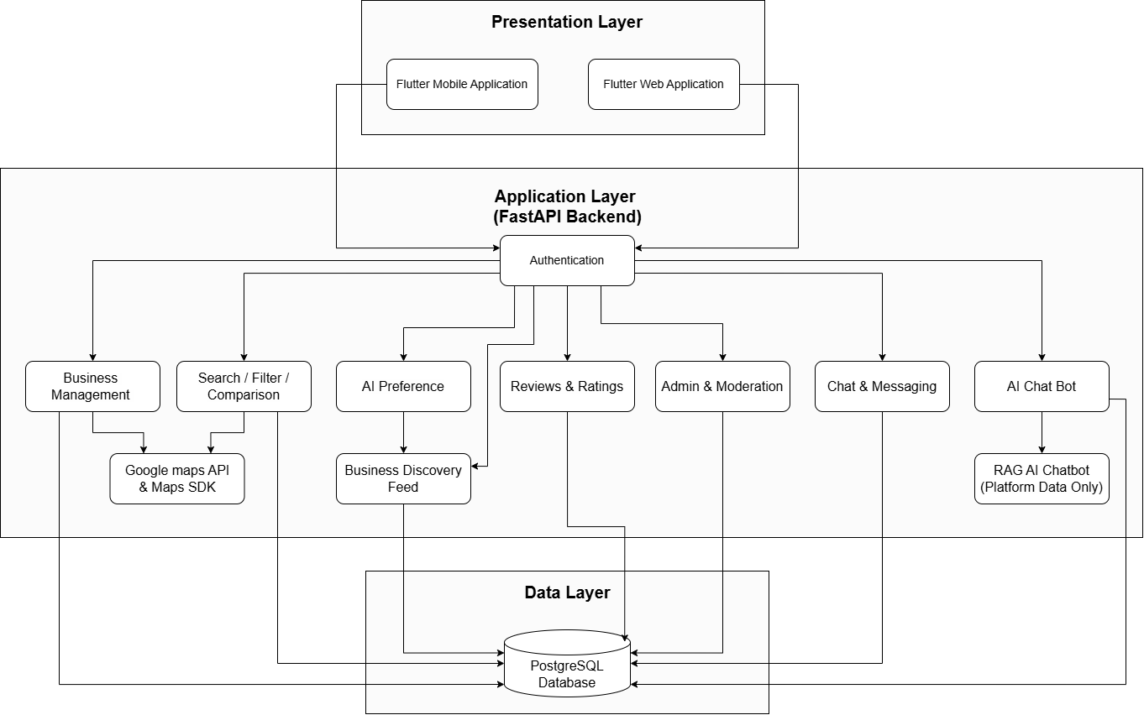
Figure 3.1 Architecture Diagram for Khojlo

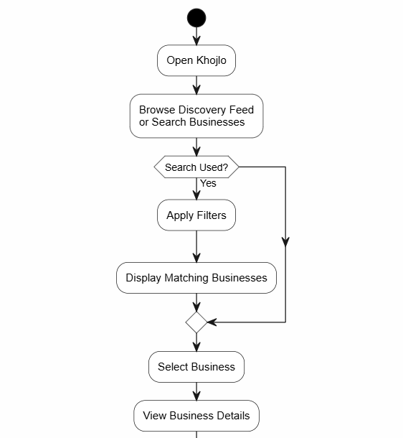
The activity diagram of the Khojlo system is shown in Figure 3.2.

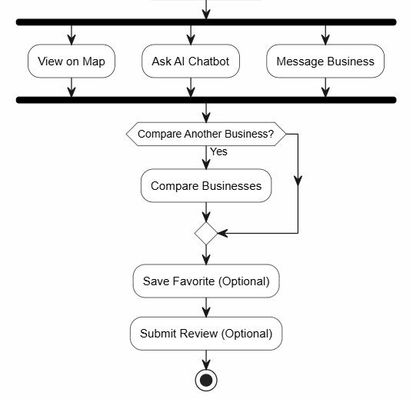

Figure 3.2 Activity Diagram for Khojlo

4.Design models

The class diagram represents the static structure of the Khojlo system by illustrating the major classes, their attributes, operations, and the relationships between them.

4.1 Class Diagram

The class diagram models the core entities of the application and demonstrates how object-oriented principles such as inheritance, association, composition, and interfaces are applied within the system.

Figure 4.1 presents the class diagram of the Khojlo system.

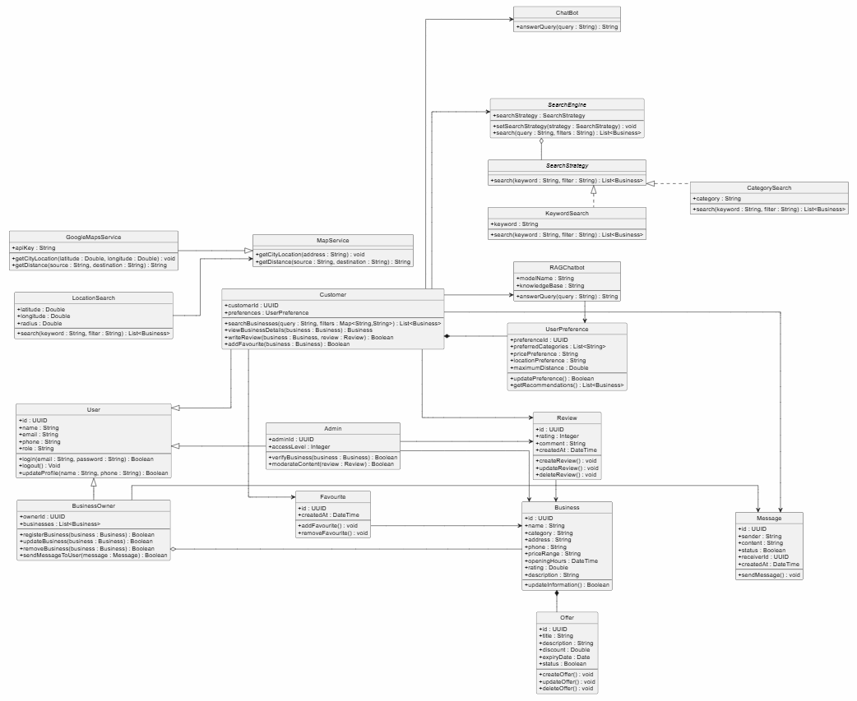Figure 4.1 Class diagram for Khojlo

The class diagram is centered around the abstract User class, from which Customer, BusinessOwner, and Admin inherit common user attributes and operations. The BusinessOwner manages one or more Business entities, while each business may contain multiple Offers and Reviews. Customers can save businesses as favourites, submit reviews, and communicate directly with businesses through the Message class.

To support extensibility, the system uses the Strategy Pattern for implementing different search mechanisms through the SearchStrategy interface and its implementations. Similarly, the MapService and Chatbot interfaces abstract external services, allowing Google Maps and the RAG-based AI chatbot to be integrated without tightly coupling the application to a specific provider. This design improves modularity, maintainability, and future scalability.

4.2 Sequence Diagram

The sequence diagram illustrates the interaction between the customer and the major software components of the Khojlo system during the business discovery process. It demonstrates how requests are processed by the application, how data is retrieved from the database, and how external services such as Google Maps and the AI chatbot are integrated to assist the user. The diagram emphasizes the chronological order of communication between the system components while performing one of the primary functionalities of the application

The sequence diagram of the Khojlo system is shown in Figure 4.2.

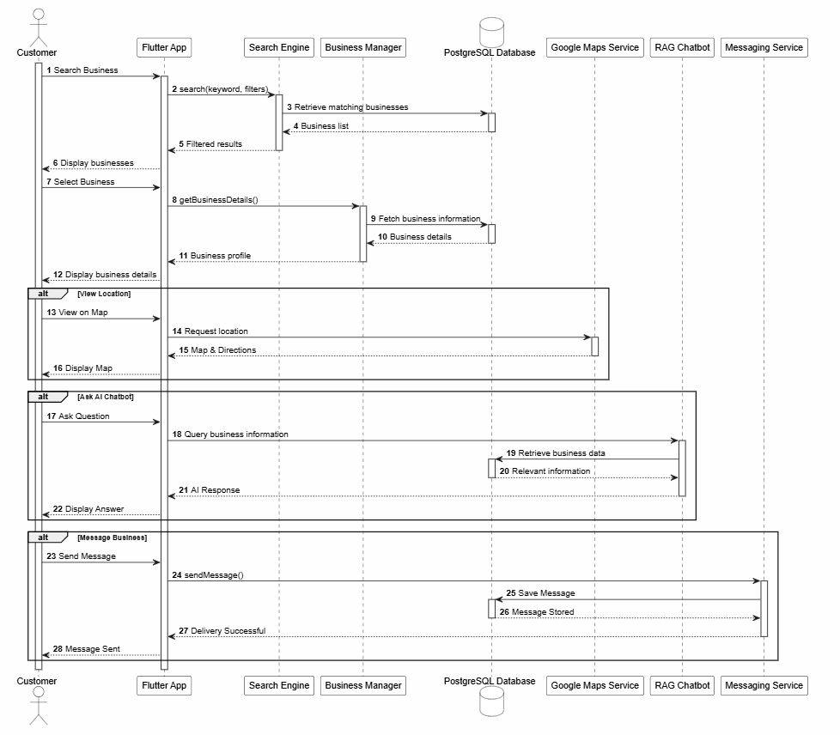
Figure 4.2 Sequence diagram for Khojlo

The sequence diagram represents the primary business discovery workflow of the Khojlo system. The process begins when the customer searches for a business through the Flutter application by providing keywords and optional filters. The search request is forwarded to the Search Engine, which retrieves the relevant business listings from the PostgreSQL database and returns the filtered results to the user interface.

After selecting a business, the application requests detailed information from the Business Manager, which retrieves the required data from the database and presents the complete business profile to the customer. From the business details page, the customer may perform additional actions depending on their requirements. The user can view the business location using the Google Maps Service, ask business-related questions through the RAG-based AI chatbot, or communicate directly with the business owner using the messaging service. Each optional interaction communicates with the appropriate subsystem before returning the requested information or confirmation to the user. This sequence demonstrates the collaboration between the application's internal components and external services to provide a comprehensive business discovery experience.

4.3 State Transition Diagram

The state transition diagram illustrates the interaction flow of a customer within the Khojlo system while discovering businesses, saving favourites, writing reviews, and communicating with business owners. It shows the different states a user passes through from being logged out to browsing businesses, viewing business details, saving businesses, submitting reviews, and initiating chat conversations. The diagram also represents the transitions triggered by user actions, providing a clear view of how customers navigate through the platform.

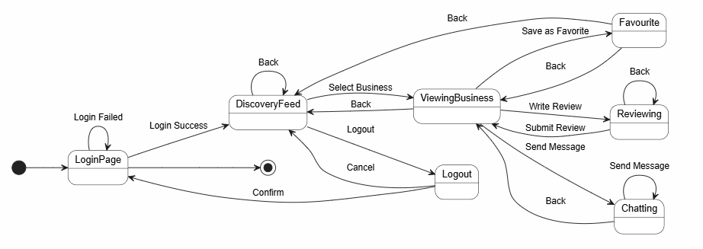
Figure 4.3 presents the state transition diagram

Figure 4.3 presents the state transition diagram

The state transition diagram models the interaction of a customer with the Khojlo platform. The user starts in the LoggedOut state and moves to LoggedIn after successful login. The customer can then open discovery, browse businesses, and view a selected business.

While viewing a business, the customer may save it as a favorite, write and submit a review, or send a message to the business owner. These actions lead to the Favourite, Reviewing, and Chatting states respectively. The customer can return to the business view from review or chat states using the back action. Finally, logging out transitions the user back to the LoggedOut state.

5. Data design
The Khojlo system follows a relational data model, where application data is stored and managed using a PostgreSQL database. The information domain identified during the analysis phase is transformed into normalized relational tables representing the major entities of the system. Each entity corresponds to a real-world object such as users, businesses, reviews, offers, favourites, and messages, with relationships established through primary and foreign keys to ensure data consistency and integrity.

The system stores user information in a centralized User entity, from which different user roles (Customer, Business Owner, and Administrator) are managed through role-based authorization. Business owners can register and manage one or more business profiles, while each business maintains its own details, geographical location, operational information, promotional offers, customer reviews, and ratings.

Customers interact with the system by searching for businesses, saving favourite businesses, submitting reviews, communicating with business owners through direct messages, and requesting information from the AI chatbot. These interactions generate transactional data that is stored separately to improve organization and scalability.

The application follows a client-server architecture where the Flutter frontend communicates with the FastAPI backend through RESTful APIs. The backend processes user requests, validates data, performs business logic, and interacts with the PostgreSQL database for data storage and retrieval. External services such as Google Maps are accessed through APIs and therefore do not maintain persistent application data. Similarly, the RAG-based AI chatbot retrieves relevant business information from the existing database instead of maintaining a separate application database.

The database design minimizes redundancy through normalization while maintaining efficient relationships among entities. This structure supports scalability, maintainability, and future enhancements without requiring significant changes to the existing database schema.

5.1 Database / Data Storage
The Khojlo system uses the following data storage components:

Database / Data Store | Purpose
PostgreSQL Database | Stores all persistent application data including users, businesses, reviews, offers, favourites, and messages.
Google Maps API | Provides location, map visualization, and navigation services. No application data is permanently stored.
RAG Knowledge Source | Retrieves business-related information from the platform database to generate AI responses. It does not maintain an independent transactional database for the application.

5.2 Data dictionary

Admin
Attribute | Type | Description
id | UUID | Unique administrator identifier
name | String | Administrator name
email | String | Administrator email
password | String | Encrypted password
phone | String | Contact number
role | UserRole | User role

Methods
Method | Parameters | Description
verifyBusiness() | businessId | Verifies a business profile
moderateContent() | reviewId | Removes inappropriate content

Business
Attribute | Type | Description
id | UUID | Business identifier
name | String | Business name
category | String | Business category
address | String | Business address
description | String | Business description
phone | String | Contact number
priceRange | String | Price category
latitude | Double | Latitude coordinate
longitude | Double | Longitude coordinate
status | BusinessStatus | Verification status

Methods
Method | Parameters | Description
updateInformation() | businessDetails | Updates business information

BusinessOwner
Methods
Method | Parameters | Description
registerBusiness() | businessDetails | Registers a new business
updateBusiness() | businessId, businessDetails | Updates business information
createOffer() | offerDetails | Creates promotional offers
replyMessage() | messageId | Replies to customer messages

Customer
Methods
Method | Parameters | Description
searchBusiness() | keyword, filters | Searches businesses
compareBusinesses() | businessList | Compares businesses
saveFavourite() | businessId | Saves favourite business
submitReview() | businessId, rating, comment | Adds a review
sendMessage() | businessId, message | Sends message to business

Favourite
Attribute | Type | Description
id | UUID | Favourite identifier
createdAt | DateTime | Creation date

Message
Attribute | Type | Description
id | UUID | Message identifier
content | Text | Message body
sentAt | DateTime | Sending time
isRead | Boolean | Read status

Offer
Attribute | Type | Description
id | UUID | Offer identifier
title | String | Offer title
description | String | Offer description
discount | Decimal | Discount value
startDate | Date | Offer start date
endDate | Date | Offer expiry date

Review
Attribute | Type | Description
id | UUID | Review identifier
rating | Integer | Rating value
comment | Text | Customer review
createdAt | DateTime | Review submission date

User
Attribute | Type | Description
id | UUID | Unique user identifier
name | String | Full name
email | String | Email address
password | String | Encrypted password
phone | String | Contact number
role | UserRole | User type

Methods
Method | Parameters | Description
login() | email, password | Authenticates user
logout() | — | Ends current session
updateProfile() | profileData | Updates user profile

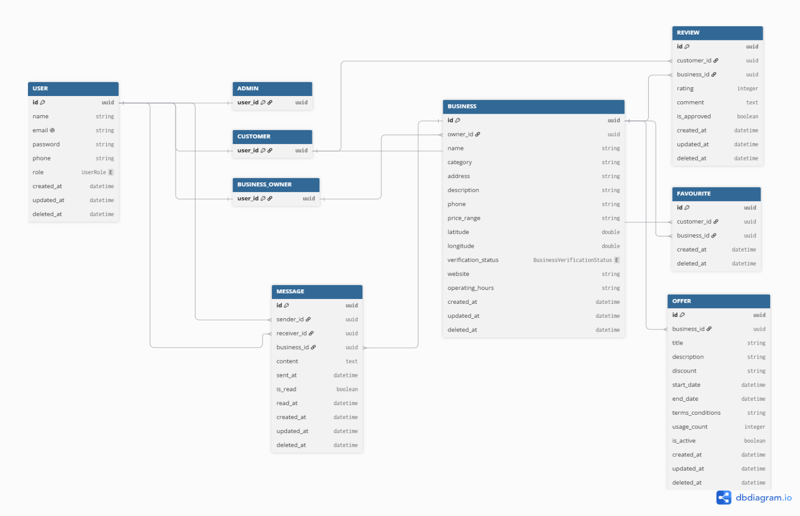
Figure 5.1 illustrates the Entity Relationship (ER) diagram for the Khojlo

Figure 5.1 ER diagram for Khojlo

6.Algorithm & Implementation
Algorithm 1: User.login()
Description: Authenticates a registered user before granting access to the system.
Pseudo Code
BEGIN Login

INPUT email
INPUT password

IF email exists THEN

Retrieve user record

IF password matches THEN
Create user session
Redirect to dashboard
ELSE
Display "Invalid Password"
ENDIF

ELSE

Display "User Not Found"

ENDIF

END

Algorithm 2: Customer.searchBusiness()
Description: Searches businesses according to the entered keyword and selected filters.
BEGIN SearchBusiness

INPUT keyword
INPUT filters

Retrieve all verified businesses

FOR each business

IF business matches keyword
AND satisfies filters

Add business to result list

ENDIF

ENDFOR

Sort results

Display businesses

END

Algorithm 3: Customer.compareBusinesses()
BEGIN CompareBusinesses

INPUT selectedBusinesses

Retrieve details of each business

Compare

Price
Rating
Services
Offers
Distance

Display comparison table

END

Algorithm 4: BusinessOwner.registerBusiness()
BEGIN RegisterBusiness

INPUT business information

Validate information

IF validation successful THEN

Save business

Set status = Pending

Notify Administrator

ELSE

Display validation errors

ENDIF

END

Algorithm 5: BusinessOwner.updateBusiness()
BEGIN UpdateBusiness

Select business

Modify information

Validate data

Save changes

IF verification required THEN

Set status = Pending Review

ENDIF

Display success message

END

Algorithm 6: BusinessOwner.createOffer()
BEGIN CreateOffer

INPUT offer details

Validate dates

Save offer

Associate offer with business

Display confirmation

END

Algorithm 7: Customer.submitReview()
BEGIN SubmitReview

INPUT rating
INPUT comment

Validate review

Store review

Recalculate average rating

Update business rating

END

Algorithm 8: Customer.sendMessage()
BEGIN SendMessage

INPUT message

Validate message

Store message

Notify business owner

Display success

END

Algorithm 9: Admin.verifyBusiness()
BEGIN VerifyBusiness

Retrieve pending business

Review business details

IF requirements satisfied THEN

Status = Verified

ELSE

Status = Rejected

ENDIF

Notify business owner

END

Algorithm 10: Admin.moderateContent()
BEGIN ModerateContent

Retrieve reported content

Review content

IF violates policy THEN

Remove content

ELSE

Keep content

ENDIF

END

Algorithm 11: SearchEngine.search()
BEGIN Search

Receive search strategy

Execute strategy

Retrieve matching businesses

Return results

END

Algorithm 12: GoogleMapsService.displayLocation()
BEGIN DisplayLocation

Receive coordinates

Request Google Maps API

Receive map

Display location

END

Algorithm 13: RAGChatbot.answerQuery()
BEGIN AnswerQuery

Receive user query

Retrieve relevant business information

Generate contextual response

Return response

END

7.Software requirements traceability matrix
Req. No. | Requirement | Ref. Item | Design Component | Component Item(s)
FR01 | User Registration and Login | Class Diagram | User | login(), updateProfile()
FR02 | User Profile Management | Class Diagram | User | updateProfile()
FR03 | Business Registration | Class Diagram | BusinessOwner | registerBusiness()
FR04 | Business Profile Management | Class Diagram | BusinessOwner, Business | updateBusiness(), updateInformation()
FR05 | Business Discovery Feed | Sequence Diagram | Business Discovery Process | Search Business Workflow
FR06 | Search Businesses | Class Diagram | Customer, SearchEngine | searchBusiness(), search()
FR07 | Filter Businesses | Class Diagram | SearchEngine, SearchStrategy | search(), apply search strategy
FR08 | Compare Businesses | Class Diagram | Customer | compareBusinesses()
FR09 | View Business Details | Sequence Diagram | Business Discovery Process | View Business Details
FR10 | View Business Location | Class Diagram | GoogleMapsService | displayLocation()
FR11 | Submit Reviews and Ratings | Class Diagram | Customer, Review | submitReview()
FR12 | Save Favourite Businesses | Class Diagram | Customer, Favourite | saveFavourite()
FR13 | Business Offers and Promotions | Class Diagram | BusinessOwner, Offer | createOffer()
FR14 | AI Chatbot Assistance | Class Diagram | RAGChatbot | answerQuery()
FR15 | Direct Messaging | Class Diagram | Customer, Message | sendMessage()
FR16 | Business Reply to Messages | Class Diagram | BusinessOwner, Message | replyMessage()
FR17 | Business Verification | State Transition Diagram | Business Lifecycle | Pending → Verified
FR18 | Review Moderation | Class Diagram | Admin | moderateContent()
FR19 | Business Moderation | Class Diagram | Admin | verifyBusiness()
FR20 | Business Status Management | State Transition Diagram | Business Lifecycle | Draft, Pending, Verified, Rejected, Suspended, Archived

8.Human interface design
Khojlo provides a simple, intuitive, and user-friendly interface that enables users to discover local businesses efficiently. The application is designed with a clean layout, consistent navigation, and responsive user interactions to ensure a seamless user experience for customers, business owners, and administrators.
When users launch the application, they are presented with the authentication screen where they can log in or create a new account. New users are guided through an AI-powered onboarding process, during which they select their preferences such as business categories and interests. These preferences are used to personalize the discovery feed and business recommendations.
After authentication, users are directed to the Discovery Feed, where they can browse newly added, trending, and recommended businesses. The application provides search, filtering, and comparison features that allow users to quickly find businesses matching their requirements. Selecting a business opens a detailed profile displaying its description, contact information, location on Google Maps, ratings, reviews, offers, and available messaging options.
Customers can submit reviews, save businesses as favourites, compare multiple businesses, and communicate directly with business owners through the integrated messaging system. Additionally, users can ask questions using the AI Chatbot, which retrieves relevant information from the platform database using the Retrieval-Augmented Generation (RAG) approach.
Business owners have access to a dashboard where they can register businesses, update business information, create promotional offers, and respond to customer messages. Administrators access a dedicated management interface to verify business registrations, moderate reviews, and remove inappropriate or spam content.
Throughout the system, users receive immediate visual feedback for all important operations. Successful actions such as login, review submission, business registration, or preference updates are confirmed through success messages. Invalid inputs, authentication failures, or system errors are communicated using clear validation messages that help users resolve issues quickly.

8.1 Screen images

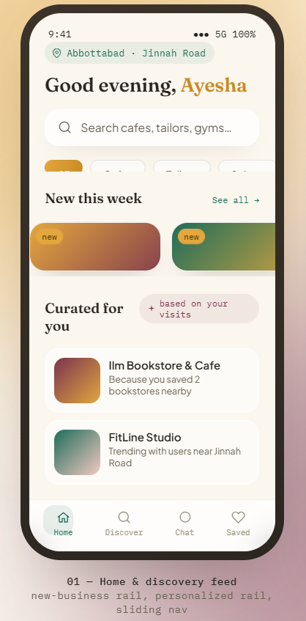
The following figures present the screen images of the Khojlo system, providing a visual representation of the application's user interface and major functional modules.

Figure 8.1

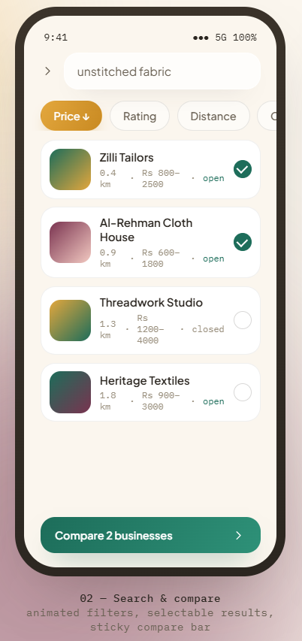

Figure 8.2

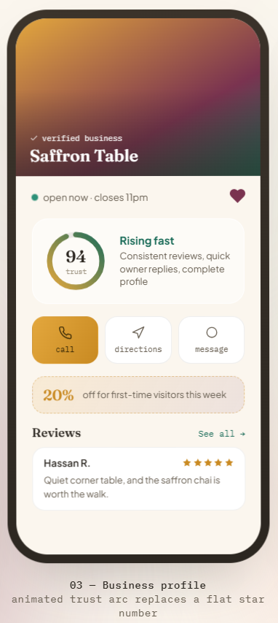

Figure 8.3

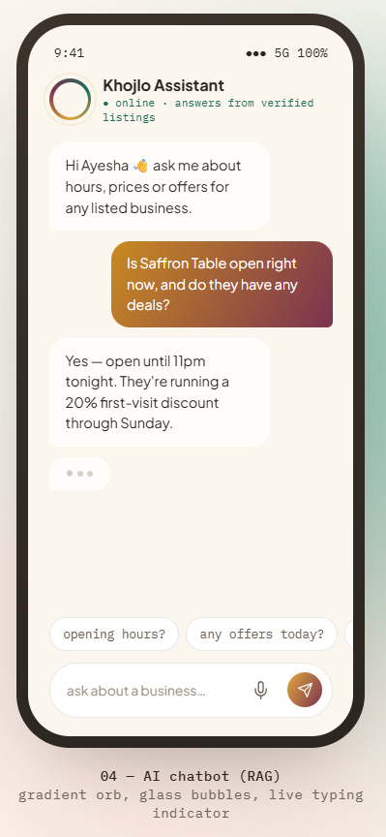

Figure 8.4

8.2 Screen objects and actions
This section describes the interface elements (screen objects) presented to the user and the actions associated with each object. The interface is designed to provide a simple, intuitive, and user-friendly experience while allowing users to efficiently discover businesses, compare services, communicate with business owners, and obtain business information through the AI assistant.

Screen 1: Home & Discovery Feed
The Home screen serves as the primary landing page after user authentication. It displays personalized recommendations, recently added businesses, and provides quick access to search and navigation features.
Screen Object | Action
Location Indicator | Displays the user's current location used for nearby business recommendations.
Greeting Section | Welcomes the user by displaying their name.
Search Bar | Allows users to enter keywords to search for businesses.
Category Chips | Filters businesses based on selected categories.
New This Week Section | Displays recently added business listings. Selecting a card opens the Business Profile screen.
Curated for You Section | Displays AI-personalized business recommendations based on user preferences and activity.
Business Cards | Displays summary information about each business. Selecting a card opens the Business Profile screen.
Bottom Navigation Bar | Provides navigation to Home, Discovery, Chat, and Saved screens.

Screen 2: Search & Compare
The Search screen enables users to search businesses, apply filters, and compare multiple businesses before making a decision.
Screen Object | Action
Search Field | Accepts keywords entered by the user to search businesses.
Filter Buttons | Filters search results based on Price, Rating, Distance, and Category.
Business Result Card | Displays business information and opens the Business Profile when selected.
Selection Indicator | Allows users to select businesses for comparison.
Compare Button | Opens the comparison view for selected businesses.

Screen 3: Business Profile
The Business Profile screen presents detailed information about a selected business and enables users to interact with the business.
Screen Object | Action
Business Banner | Displays business name and verification status.
Favorite Button | Adds or removes the business from favorites.
Availability Status | Shows whether the business is open or closed.
Trust Score | Displays the AI-generated trust indicator.
Call Button | Initiates a phone call.
Directions Button | Opens Google Maps navigation.
Message Button | Opens direct messaging with the business.
Offer Banner | Displays active promotional offers.
Reviews Section | Displays customer reviews and ratings.
See All Button | Opens the complete list of reviews.

Screen 4: AI Chatbot Assistant
The AI Chatbot screen enables users to ask questions regarding businesses listed on the platform using Retrieval-Augmented Generation (RAG).

Screen Object | Action
Chat Header | Displays chatbot identity and status.
Chat Messages | Displays the conversation.
Suggested Questions | Provides predefined questions.
Text Input Field | Allows the user to type a query.
Voice Input Button | Enables voice queries.
Send Button | Submits the query.
AI Response Area | Displays responses using verified Khojlo business data.

